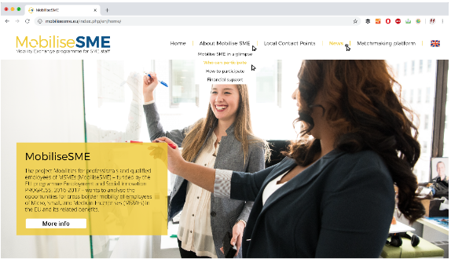
Title (Mr, Ms, Mrs)*:
First name*:
Last name*
Company Name*
Category (choose one): Micro enterprise, small enterprise, medium sized enterprise
self-employed or large enterprise.
Nº employees:
VAT number:
Company website*:
Year established:
Languages (indicate there you are comfortable to work with)
Business sector:
Do you want to receive or send employees? (HC/SC)*: Host Company or Sending Company
Type of activity interested: (multiple choice, choose as many as you want)
- Market research/marketing strategies in other markets/territories.
- Innovation/development of new products or services.
- Joint trainings in critical sectors for either of the participants.
- Research and collaboration to find possible clients in foreign markets
- Other (specify in the short description and motivation of participation)
Address:
City:
Country:
Telephone *:
Website (if any):
Skype ID (if any):
Email*:

*Possibility of hiding the information due to privacy purposes. All fields are compulsory

Short description of the company and motivation (3000 characters)

Provide information that covers the following points:
- Main features and characteristics of your company, apart from those expressed above.
- Advantages(s) offered by your company and why it should be selected by potential business partners.
- Explain why it makes you a good business partner: avoid generalities (e.g. reasonable prices, high quality staff, unique, innovative, etc.), be specific (e.g. quantifications, certification, past international successes etc.).
- Describe past international experience; products; services; field of activity; applications, competitive advantages and type of co-operation sought
- Reasons for you participating in the Mobilise SME programme.
- How your stay abroad could help you to develop your business, product, etc.
Show that your company matches with the kind of company you aim to collaborate with and that you have experience in your field of expertise.

What type of business partner are you looking for? (2000 characters)

Provide information about the type and the role of the partner sought. Insert detailed information and this will allow prospective partners to be fully aware of your needs and expectations.

The field should address the following information:
· The type of partner sought (industry, academic,, business etc.)
· The tasks and activities you would like to be performed by the partner sought

After filling out this form, send it to your local contact point. For more information, go to https://mobilise-sme.eu/local-contact-points/

